# 

**2015**

# Achievement Standard 91393 (v1)

Demonstrate understanding of oxidation – reduction processes

**Practise Assessment**

NAME

|  |  |  |
| --- | --- | --- |
| **Achievement** | **Merit** | **Excellence** |
| Demonstrate understanding of oxidation – reduction processes | Demonstrate in-depth understanding of oxidation – reduction processes | Demonstrate comprehensive understanding of oxidation – reduction processes |

**Question One**

A simplified diagram of a cell used in the electrolysis of molten aluminium oxide, Al2O3(*ℓ*), is shown below.

[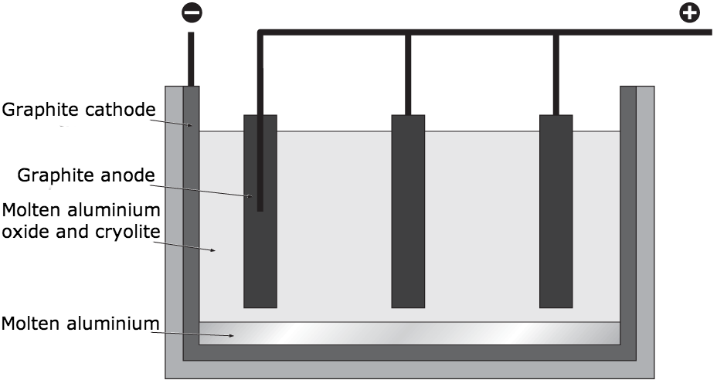](https://www.google.co.nz/url?sa=i&rct=j&q=&esrc=s&frm=1&source=images&cd=&cad=rja&docid=goha-ciMbPJ9DM&tbnid=ewuF5qfwYO448M:&ved=0CAUQjRw&url=https://www.clevernotes.ie/chemistry/hl/leaving-cert/sample-answers-2012-section-b-3/&ei=w2YWU-bFKIuGkgXLmYDoDg&bvm=bv.62286460,d.dGI&psig=AFQjCNGw6sCRPgEcMKHZShYqinFsQKDNRg&ust=1394063112362775)

The negative electrode is the graphite lining of the steel tank, and the positive electrodes are carbon blocks, which can be lowered into the molten aluminium oxide.

Discuss what occurs in the electrolysis of molten aluminium oxide.

Your answer must include:

* the movement of ions and electrons
* substances formed at the anode and the cathode
* balanced equations for reactions at both the anode and the cathode
* identification of the oxidation and reduction reaction, with reasons (loss/gain of electrons or increase/decrease of oxidation number)
* observations linked to the species involved at both the anode and the cathode

**Question Two**

An electrochemical cell is to be set up to investigate the following redox reaction

Cu2+(aq) + S2O32-(aq) → Cu(s) + S4O62-(aq)

(a) Label the diagram with the solutions used and the materials of the electrodes

(b) Indicate the direction of current flow across the voltmeter

Salt bridge   
[KNO3(aq)]

**Question Three**

The following data is to be used to set up an electrochemical cell

|  |  |
| --- | --- |
| **Redox couple** | ***E*o /V** |
| Fe3+/Fe2+ | 0.77 |
| Br2/Br- | 1.09 |

(a) Write out both half-equations together with the overall redox reaction for the cell. Identify which half equation is oxidation and which is reduction

(b) Complete a cell diagram in IUPAC notation for the cell

(c) Calculate the voltage generated by the cell under standard conditions

**Question Four**

Swimming pools contain dissolved chlorine to prevent infection and disease.

*E*º(Cu2+/Cu) = +0.34 V *E*º(Al3+/Al) = –1.66 V *E*º(Cl2/Cl–) = +1.36 V

Use the data above to determine whether copper or aluminium pool fittings would be more readily oxidised by dissolved chlorine. Give a full explanation for your answer.

**Question Five**

Glucose, C6H12O6, is oxidised by dissolved oxygen to form carbon dioxide and water.The standard reduction potentials and equations are

*E*º (volts)

6CO2(g) + 24H+ + 24e– rarrow C6H12O6 + 6H2O -0.01

O2(g) + 2H2O + 4e– rarrow 4OH– 0.40

a) Write the overall balanced equation for the reaction in which glucose is oxidized by dissolved oxygen.

The above reaction could be used to generate electricity in an electrochemical cell. In one half-cell, oxygen gas is bubbled over a suitable electrode immersed in a hydroxide solution while the other half-cell consists of a suitable electrode immersed in glucose solution.

b) Suggest a suitable material for the electrodes of this cell. Give an explanation for your choice.

c) Circle the flow diagram which correctly describes the direction of flow of electrons through the external circuit.

Glucose solution

Oxygen gas /hydroxide solution

Oxygen gas /hydroxide solution

Glucose solution

Give an explanation for your choice

d) Calculate the voltage generated by the cell under standard conditions.

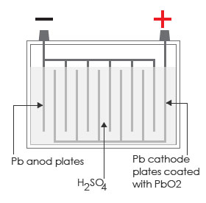**Question Six**

The following diagram represents the lead-acid battery often used in cars.

The following reactions occur when a car battery is operating:

Pb + SO42– → PbSO4 + 2 e **Reaction 1**

PbO2+ 4 H+ + SO42– + 2 e– → PbSO4 + 2 H2O **Reaction 2**

a) Circle the reaction which occurs at the **anode** and give a reason for your answer.

b) Discuss the changes to the following cell components when the battery is operating and link the observed changes to the species involved.

* Lead plates
* Lead oxide coating
* The sulfuric acid concentration

c) The lead acid battery is a rechargeable battery, when external energy is supplied to the battery it recharges.Discuss what this means.

Include the following in your discussion:

* What happens to the electrodes during the recharge process
* The movement of electrons
* The reduction- oxidation reactions occurring at each electrode.